Lab1: In-class activity
Mark:10

Introduction to Packet Tracer

Learning Objectives:
- Explore Packet Tracer Real-time mode
- Explore the Logical Workspace
- Explore Packet Tracer operation
- Connect devices
- Examine a device configuration
- Ping, Ipconfig /all
Note: you should have downloaded and installed Packet Tracer (PT) and Wireshark (WS) from the pre-lab1. Pay attention to terminologies and steps you are going through in this lab. You will be questioned on each lab during the demo and the upcoming quizzes. Remember always to save your PT for future use.
Log in to PT and set up two networks

When you try to open PT for the first time, it will ask you to log in or sign in to the Network Academy. Click on the blue tab (Networking Academy) and log in with your Algonquin College credentials (username and password).
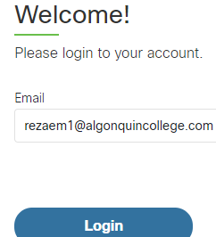
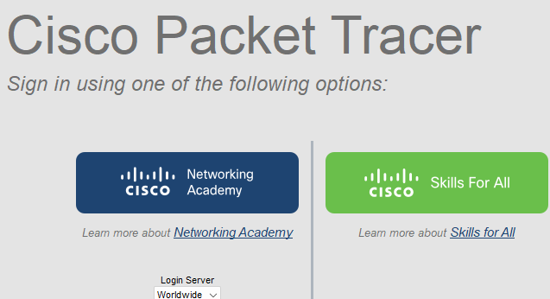

Background:
The simulator that is used in this course is Packet Tracer. PT provides a rich set of protocols, equipment, and features but only a fraction of what is possible with real equipment. Packet Tracer is a supplement not a replacement for experience with real equipment. You are encouraged to compare the results obtained from Packet Tracer network models with the behavior of real equipment.
This activity will allow exploring the standard lab setup using the Packet Tracer simulator. Packet Tracer has two file formats it can create: .pkt files (network simulation model files) and .pka files (activity files for practice). When you create your networks in Packet Tracer or modify existing files from your instructor or your peers, you will often use the .pkt file format. When you launched this activity from the curriculum, these instructions appeared. They are the result of the. PKA, Packet Tracer activity file format.

Overview of the devices
The standard lab setup will consist of one router, two switches, and four PCs. Each of these devices will be set up and configured manually by you. Such information as device names, IP addresses, gateways, and connections.

Logical Workplace
When Packet Tracer starts, it presents a logical view of the network in real-time mode. The main part of the PT interface is the Logical Workplace. This is the large area where devices are placed and connected.
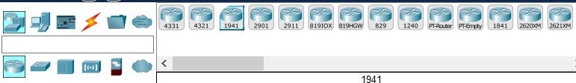

Symbols Navigation
The lower left portion of the PT interface, below the yellow bar, is the portion of the interface that you use to select and place devices into the logical workplace. The first box in the lower left contains symbols that represent groups of devices. As you move the mouse pointer over these symbols, the name of the group appears in the text box in the center. When you click on one of these symbols, the specific devices in the group appear in the box to the right. As you point to the specific devices, a description of the device appears in the text box below the specific devices. Click on each of the groups and study the various devices that are available and their symbols.

Choosing end-device, intermediary, and cables to set up a physical topology

At the bottom of the screen highlight the router icon, choose router 1941, and drag it to the Logical workplace (white area-router0)

Highlight the switch icon, choose two 2960-24TT (switch0 and switch1), and drag them to the Logical workplace one by one.

Highlight the end device icon, choose PC, and drag 4 PCs (0 to 3), into the Logical workplace.

How to delete or rename devices
There are two options for deleting or renaming devices:
Deleting devices:
- Click on any device and drag it to the Logical workplace, PT always names the device from zero (0), like PC0, Switch0, Router0, and so on. If you want to delete a device, click on the delete icon, and your mouse becomes an X. Click on the device and delete it.


Now click on the Logical tab, and your mouse changes to an arrow again.
Renaming a device:
- You can rename the devices by clicking on Place Note and rename the device.
Click on PC0 once, it opens a small box, rename it to PC1. Make sure all devices have the same name according to the topology diagram before you continue.
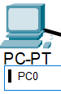
What is a topology? (1 mark) _____________
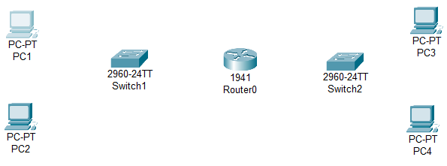

Topology diagram
Make sure all devices have names
according to this topology

Devices connections: (cables)

Straight- through used for connecting two different devices like a PC to switch, or a router to switch.

Cross-over cable: used for connecting the same devices as switch to switch, PC to PC, router to router, PC or server to router. _ _ _ _ _ _
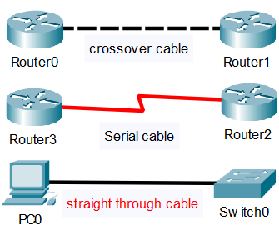

Serial cable: connects routers or devices to the internet

Connect all devices with the Copper Straight-through cable to create a local network.

Highlight the connection icon (Left-organ line) and choose Copper straight-through cable.
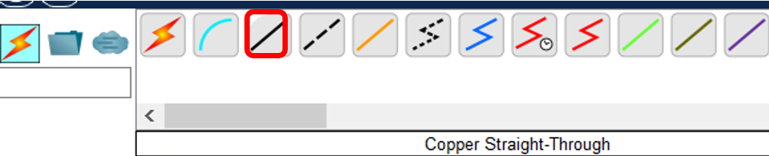

1-Click on the solid line / (like a forward slash) your mouse becomes like a hammer. You will see PC1 with the FastEthernet0 port. Drag the hammer to switch1 and choose the first FastEthernet 0/1.

2-Repeat this action for the PC2, choose Fastethent 0/2 on switch1

3-From switch1 find FastEthernet 0/10, click on router0 choose

GigabitEthernet0/0 and connect switch1 to router0.
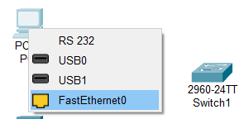

4-Now do the same connections for the PC3, PC4, switch2, and router0

Pc3: FastEthernet0 to swtich2, port FastEtherner0/1

PC4: FastEthernet0 to swtich2, port FastEtherner0/2

Switch2: FastEthernet0/10 to router0, port GigabitEthernet0/1

Implementing static IP addresses on all PCs and router0 (4 Marks)

First network (left)

1-click on the PC1, choose the Desktop tab, and then click on the IP Configuration icon. Make sure the static radio button is highlighted.
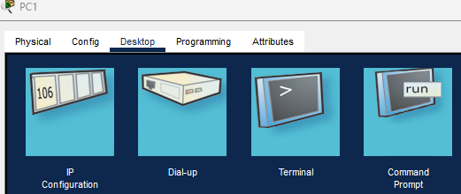

Enter IPv4 address: 192.168.1.1

Subnet mask: 255.255.255.0

Default gateway: 192.168.1.10

click on X to save the settings.
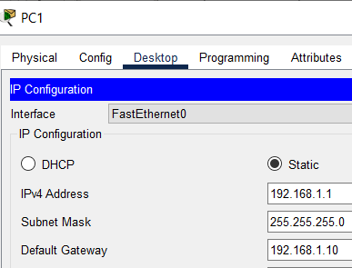

PC2:

IPv4 address: 192.168.1.2

Subnet mask: 255.255.255.0

DG: 192.168.1.10

Router 0:

click on router 0, choose the config tab, and under the Interface

choose GigabitEthernet0/0.

IPv4 address: 192.168.1.10 Subnet mask: 255.255.255.0

Check marks the on box (to turn on the router’s port). The triangle between router0 and switch2 in PT becomes green.
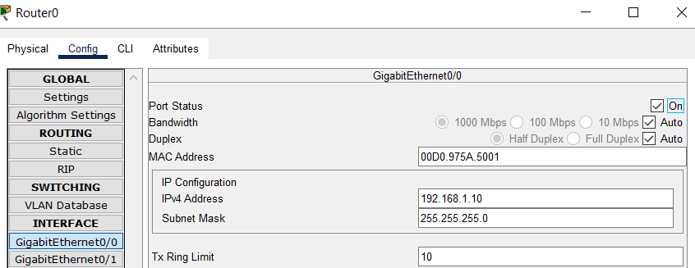

Second network: (right)

PC3:

IP address: 192.168.5.3

Subnet mask: 255.255.255.0

DG: 192.168.5.10

PC4:

IP address: 192.168.5.4

Subnet mask: 255.255.255.0

DG: 192.168.5.10

Router 0:

GigabitEthernet0/1: 192.168.5.10

Subnet mask: 255.255.255.0

Check box on (to turn on the port)

Notice the triangles between router0 and switches are RED. That is because the interfaces (port) for router0 do not have an IP address yet. As soon as you configure the IP address for the interfaces the triangles become GREEN. The switch does not need any IP addresses at this time.
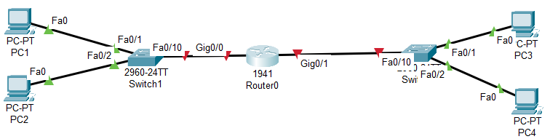

Test the device's connectivity. (1 mark)

Ping is a command to test device connectivity with an IP address

Ipconfig /all is a command that shows the device's IP address, subnet mask, default gateway, physical address (MAC), DNS, DHCP, and so on.

1-Click on PC1, choose the command prompt tab, and ping PC2, type: ping 192.168.1.2, and press enter.

Insert the Screenshot here

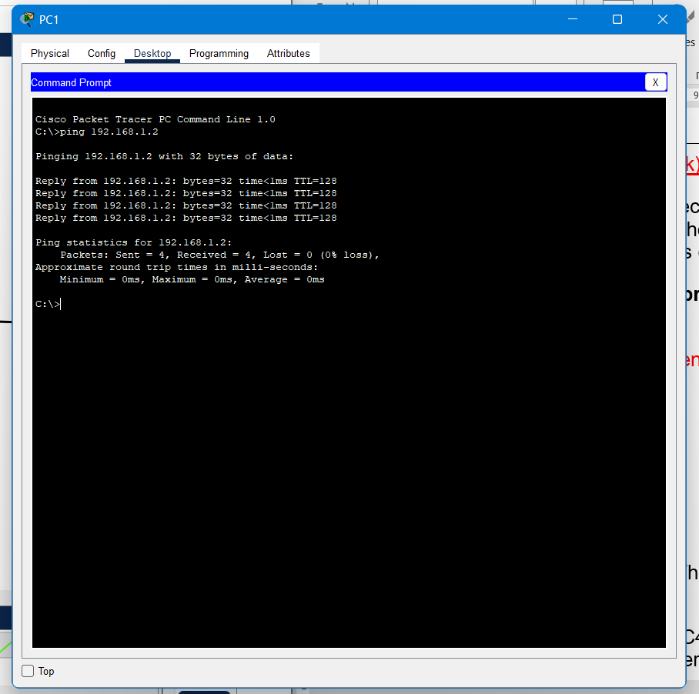

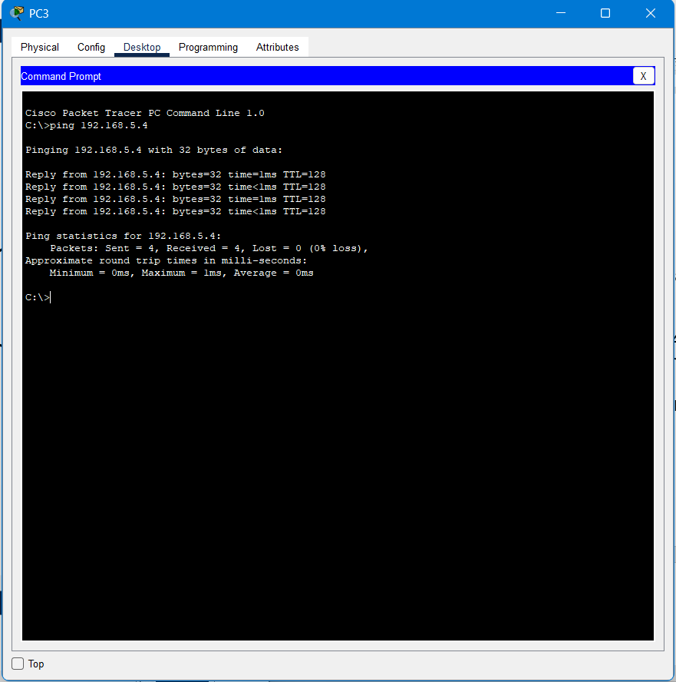

You should see 4 TTL (Time To Live). That means PC1 and PC2 are connected.

2-Do the same thing and ping PC3 to PC4. The result should be the same. All PCs should be able to ping each other.

Save the PT with a lab1-your-name example: lab1-mike-rezae

How to add Modules or serial ports to the 1941 router (1 mark)

1-Click on the router0

Note: router 1941 does not have serial connections by default, therefore you must manually add two modules to the router. (black boxes)
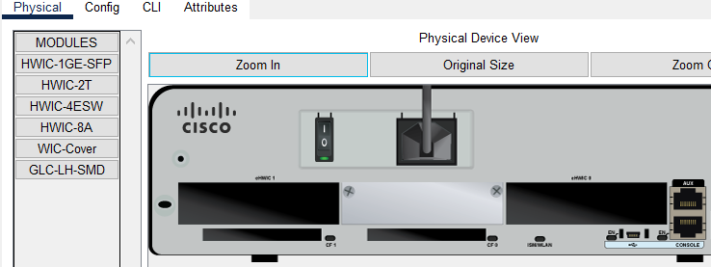

1-Double-click on router0 1941, choose the physical tab, and then click on HWIC-2T. You will see a module at the bottom, right of the screen.
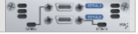

2-Click on the power button and shut down the router.

3-Drag and drop the module into the left slot first (Module 1) and again drag the second module to the right slot. (Module 2)

4-Turn on the router again.
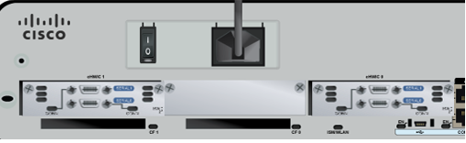

5-Click on the config tab. Now you

see the serial ports (serial 0/0/0) in the router

How to use the simulation tab in PT (3 Mark)

1-Click on the simulation tab at the bottom right and choose Edit filter

2-Uncheck all the boxes except ARP and ICMP
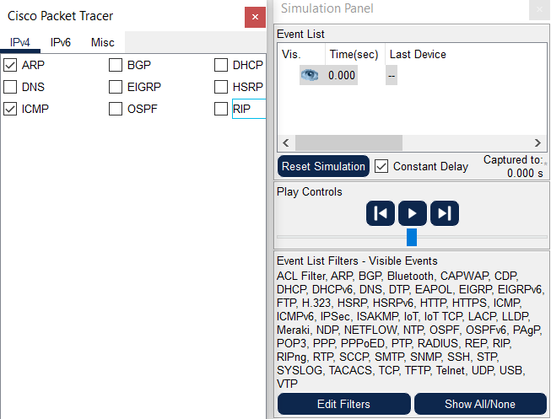
3-Click on the Realtime tab, click on Add simple PDU
(Envelope on the top) and drag it on PC1 and then on PC3.

4-Click on PC1, go to the command prompt tab, and
Ping PC4, ping 192.168.5.4
5-Click on the simulation tab and click on the play button to
capture PDU (Packet Data Unit)
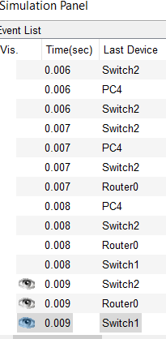
6-Click on || to stop the simulation.
7-Click on any PDU packet and examine it. Check the
OSI model and Inbound
PDU Details tabs for the packet details.

OSI Model tab:
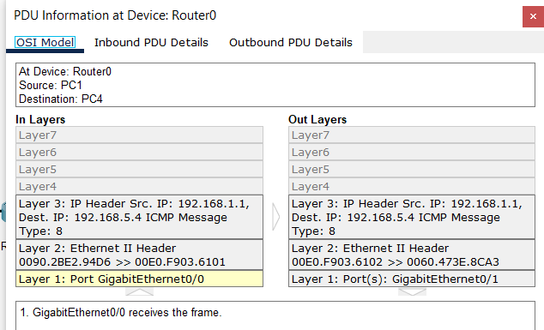

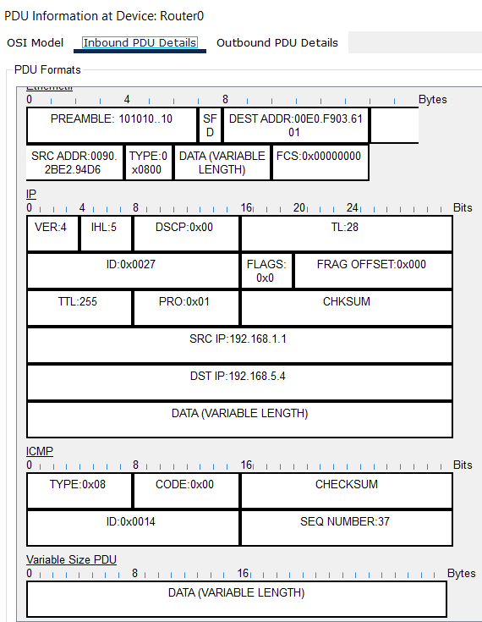
Inbound PDU Details tab:

You have completed your Packet
Tracer Lab.
Demo your lab in class to your lab instructor.

